Rugby Canoe Club Organised Trip Pack
Thank you for taking on the responsibility of organising a trip for the club. As a club we rely on the efforts of our members and coaches to enrich our offerings within the club. This document has been put together to help you in organising the trip.
Before a trip is advertised, and in order to meet current BC requirements, can the following items be adopted, in the order shown below, to assist the committee to grant approval:
- Read the RCC Generic River Risk Assessment Sheet. If this does not meet the hazards of a trip contact the Safety Officer on the Committee (Annex A)
- Read the BC Definitions – grading (Annex B)
- Read the Weir Features Reminder (Annex C)
- Complete and submit the RCC Trip Management Plan to the Committee Secretary secretary@rugbycanoeclub.org.uk (Annex D)
- Create a Trip Advert (Annex E example) and circulate to Facebook Event page & Newsletter Editor
- Complete Booking sheet (Annex F)
- Complete Boat Hire Sheet - if applicable (Annex G)
- Complete Emergency Contact Sheet and ensure it’s carried by Organiser / Leader whilst on the water (Annex H)
- Complete the Float plan (Annex I) on the day of the trip and leave with an emergency contact. It is important it is updated if plans change.
CONSIDERATIONS WHEN ORGANISING A TRIP
Deposits/Payments:
If the trip involves any payments in advance for example accommodation or facility booking fees then this should be agreed in advance with the committee. The club does not expect event organisers to take personal financial responsibility for losses. In these cases all transactions for payments and income related to the trip must go through the club accounts. Proper records of both payments and receipts need to be generated. Invoices and receipts should be given to the treasurer as soon as possible. If you need to make personal payments on the club’s behalf they will be refunded subject to the agreement you made with the committee and suitable evidence, like receipts.
When charging participants on the trips, the amount taken should aim to cover costs that the club is committed to honour. Thus any deposit should for example, cover any cancellation fees that we would incur. The total cost should cover the total expected costs of the trip.
Once a deposit is paid, confirmation is at the discretion of the trip organiser. Things you might need to consider when confirming places might include:
- The balance of ability, ensuring you have enough experienced paddlers on the trip is important to the safety of those participating.
- Suitability of trip to individual’s skills, participants may need help in understanding required ability to be on the trip without putting others or themselves at risk. You may want to discuss this with your elected Leader or coach who is more familiar with the paddler’s ability.
All places should be booked via club booking form. Try and inform those taking money on the reception desk regarding spaces available.
Trip organiser needs to know who requires a kit (boats, paddles, etc) and arrange a collection time.
Accommodation
This will have to be booked well in advance and a deposit paid to secure any booking. Once this has been done, the date can go in the calendar.
Trip organisers should familiarise themselves with the emergency procedures and rules at the accommodation, passing this information on to others on the trip.
If a trip has a lot of interest you might want to consider if it would be beneficial to help organise alternative accommodation, sometimes this might not be a good idea for increased complexity in organising both on and off the river.
Safety
As trip organiser you will need to appoint a river leader who is responsible for overseeing a dynamic risk assessment on the water. It is recommended that the trip organiser does not take on this role.
Trip organiser and leader should familiarise themselves with the generic risk assessment for the trip they are running and make any trip specific additions. Continuous dynamic risk assessment should continue throughout the trip. (Annex A).
Trip organiser is responsible for arranging any safety kit required for the trip (eg. Club first aid kit).
A list of emergency contact telephone numbers, medical conditions and medications should be compiled and made accessible whilst ensuring privacy is maintained. The list should be carried by the leader on the water. Trip organiser needs to ensure any participants with medical conditions have any necessary medication prior to leaving for the trip. Any specific medical conditions requiring assistance should be discussed with the trip leader and trip first aid. (Annex H).
Stand Up Paddleboard Safety Mitigation
Attention should be paid to techniques to mitigate against the use of leashes. Leaders / Coaches should focus on:
1. Active Height Management - encouraging paddlers to lower the centre of gravity prior to potential hazards (bank, rocks, rapids, drops) by adopting the kneeling or high knee posture and the use of active support tripod stance.
2. Fins - ensure that the equipment is suitable for the conditions, with a focus on the board and length of fin to reduce snagging.
3. Falls - ensure paddlers adopt the correct falling technique. Adopt active height management to reduce falls, secondly fall on your board for quick recovery, fall and swim on water surface to minimise foot entrapment issues.

Annex A Generic Risk Assessment for Canoeing, Kayaking and SUPS at Any Location
Hazard | Who might be harmed? | How might the risk be adequately controlled? | Additional Comments?
LOADING & UNLOADING | Paddlers & Others | Training in manual handling techniques | Regular checks on equipment e.g. straps / roof rack.
WATER – drowning pins entrapment | Paddlers & Others | Adequate safety cover & group control  Correct clothing & equipment  Ability level – appropriate to the conditions | Appropriate safety training
HYPOTHERMIA / HYPERTHERMIA | Paddlers | Advised on the correct clothing to wear  Adjustment to clothing as required  Awareness of changing weather  Awareness of cold water immersion | Continuous dynamic risk assessment
SLIPS TRIPS & FALLS | Paddlers | Knowledge of access & egress points and awareness of river / canal bank condition. Appropriate first aid kit | Continuous dynamic risk assessment
POLLUTION AND WATER QUALITY | Paddlers | Advised to bathe soon after immersion  Made aware of flotsam Wash hands | Risks higher in spate conditions. Avoid intentional capsizes in poor conditions
OTHER RIVER USERS | Paddlers & Other River Users | Paddlers instructed to be aware of other river users and how to take appropriate/avoiding action. | Inform as to possible other river users and location
WEIRS AND MAN MADE FEATURES | Paddlers | Helmets, buoyancy aids and appropriate clothing  to be worn when paddling in associated rough water. Appropriate rescue equipment to be carried by leader & nominated other persons  Personal paddling skills | Appropriate skill and awareness training
OVER HANGING TREES OR STRAINERS / ROCKS / STOPPERS / UNDERCUTS / SIPHONS | Paddlers | Paddlers advised to negotiate around trees, both overhanging and floating and we are aware and manoeuvre around rocks. Advised as to correct action in event of entanglement / pin / swim  Ability to recognise undercuts / syphons  Personal paddling skills | Continuous dynamic risk assessment.
PROPERTY &  FACILITIES | Paddlers & Others | Ensure accommodation is fit for the needs of the group | Continuous dynamic risk assessment.
WEATHER AND  ENVIRONMENTAL  CONDITIONS | Paddlers & Others | Monitor weather forecast  Monitor road conditions  Monitor river levels | Continuous dynamic risk assessment.
CLOTHING & PERSONAL KIT | Paddlers | Ensure clothing is correctly fitted  Ensure that the “clean line” policy for clothing is adopted e.g. no long straps on buoyancy aid  Ensure footwear is appropriate  Ensure laces are not long  Ensure kit is secured correctly in craft | Continuous dynamic risk assessment by paddlers using buddy system e.g. check your fellow paddler
RESCUE KIT | Paddlers | Ensure paddlers carrying kit have had appropriate training in their use and are carrying an appropriate knife | Appropriate BC safety update
Stand Up Paddle Boards | Leashes | All paddle boarders must wear the appropriate leash for the water that is being paddled. Where snagging and tangling is a potential risk or on any grade 2 water or above | Continuous dynamic risk assessment
Stand Up Paddle Boards | Trip Leaders | Trip leaders should ensure that SUP paddlers have sufficient skills and experience to paddle the grade of river
Stand Up Paddle Boards | Weirs | Paddle UK discourage the use of SUPs on weirs and recommends that they should be portaged. RCC has adopted this policy.
Stand Up Paddle Boards

Annex B - BC Definitions

The following definitions are taken from the British Canoeing Environmental Definitions and Deployment Guidance for Instructors, Coaches and Leaders V1-3 dated Apr 18.
British Canoeing Definitions

They are included here for ease of reference, but the latest version should be checked whenever necessary. Where wind strengths or wave heights are mentioned these are as forecast.

Very Sheltered Water (VSW)
Quiet canals with easy bankside access and egress; small lakes, which are not large enough and do not have difficult landing, where problems could occur if there is a sudden change in conditions; gentle, slow moving rivers.
Coach to participant ratio 1:8.

The definition implies weather conditions that are not in themselves likely to cause problems. At any point, the paddler should not be more than 50 metres from the bank.

Enclosed swimming pools are also defined as very sheltered water environments.

Note: The definition implies normal conditions and care is advised when water and air temperatures are low.

Sheltered Water (SW)
Ungraded sections of slow moving rivers where the group could paddle upstream against the flow (not involving the shooting of, or playing on, weirs or running rapids). Areas of open water (e.g. lakes and lochs) where the paddlers are no more than 200 metres offshore and the wind strength does not exceed Beaufort force 3, avoiding the group being swept/blown out of the safe working area. Slow moving estuaries (less than 0.5 Knots).
Coach to participant ratio 1:8.

Examples: Small enclosed bays, enclosed harbours where there is minimal possibility of being blown offshore, defined beaches with easy places to land throughout, no tide races, over-falls or surf.

Note: The definition implies normal conditions and care is advised when water and air temperatures are low.

Moderate Water (MW)
Large areas of open water that exceed the sheltered water definition, where the paddlers are no more than 500 metres off shore and in wind strengths that do not exceed Beaufort force 4.
Grade 2(3) white water or equivalent weirs.
Coach to participant ratio 1:6.

Advanced Water (AW)
Large areas of open water which exceed Moderate Inland Water and/or have winds in excess of Beaufort force 4.
Grade 3 white water for canoe. Rivers up to and including grade 4(5) for kayak
Coach to participant ratio 1:4.

Note:
- The man-made facilities of Holme Pierrepont, Lee Valley (excluding the Olympic Channel), Teesside and Cardiff are considered to be Moderate White Water. All recognised UK slalom venues are considered to be either Sheltered or Moderate White Water except those listed below as being Advanced White Water.
- Grade 2(3): the overall standard of the run is grade 2, but there may be a few (normally one or two) grade 3 rapids that can be portaged if required.
- The following recognised UK slalom venues are considered to be Advanced White Water: Lee Valley Olympic Channel, Grandtully slalom site (1m+ gauge), Bala Mill (>12 cumec), Tryweryn (International site>12 cumec, Graveyard >9 cumec), Serpent's Tail (high water, water above rocks on main rapid).
- Grade 4(5): the overall standard of the run is grade 4, but there may be a few (normally one or two) grade 5 rapids that can be portaged if required.

River Grades

Ungraded | Ungraded sections of slow moving rivers where the group could paddle upstream against the flow (not involving the shooting of, or playing on, weirs or running rapids).
Grade 1 | Moving water with occasional small rapids. Few or no obstacles to negotiate.
Grade 2 | Small rapids featuring regular waves. Some manoeuvring required.
Grade 2(3) | The overall standard of the run is grade 2, but there may be a few (normally one or two) grade 3 rapids that can be portaged if required.
Grade 3 | Most rapids will have irregular waves and hazards that need avoiding. More difficult manoeuvring will be required but routes are normally obvious. Scouting from shore is occasionally necessary to maintain line of sight.
Grade 4 | Large rapids that require careful manoeuvring. Scouting from the shore is often necessary and rescue is usually difficult. Kayakers should be able to roll before tackling these rapids. In the event of a mishap there is significant risk of loss, damage and/or injury.
Grade 4(5) | The overall standard of the run is grade 4, but there may be a few (normally one or two) grade 5 rapids that can be portaged if required.
Grade 5 | Extremely difficult – long and very violent rapids with severe hazards. Continuous, powerful, confused water makes route-finding difficult and scouting from the shore is essential. Precise manoeuvring is critical and for kayakers, rolling ability needs to be 100%. Rescue is very difficult or impossible and in the event of a mishap there is significant hazard to life.

Annex C Weir Features and Hazards Reminder

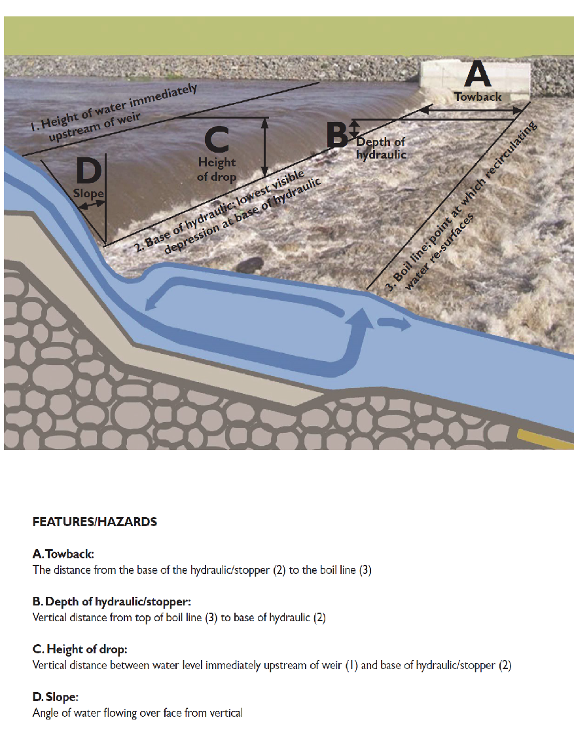

Annex D - RCC Trip Management Plan (To be completed and submitted to Committee for approval)
In signing this plan you are acknowledging that you have read and understood the Generic River Risk Assessment sheet & BC Definitions

Is the generic risk assessment sufficient for the potential hazards of the planned trip?  (Annex A) | YES
What is the location of the trip? | Nene White Water Centre Northampton
Date and Time of trip: | 15th July 2021 7pm - 9pm
Trip Organiser: | Chris Fawcett
Trip Leader: | Not applicable
Trip First Aider: | Chris Fawcett
BC Environmental Definition  (Annex B) *Delete as applicable | SW
Coach Requirements?  BC qualified personnel (Annex B) | 1 - 6
How will fees be collected (if required)? | Zettle
Outline of Trip
Note – Describe what you will be doing.
Introduction to moving water, on an artificial man made course. 2 pumps in operation, pumping water from the River Nene into and out of the course.

*Mandatory Requirement (Committee Minutes and Email Confirmation)
*Committee Approval | YES / NO

Annex E Advertising
You should provide your planned trip details to the committee. Once confirmed, details should be sent to members, in order to advertise details and create a booking form. This should be done at least 6 weeks prior to the trip where possible.
Details should include:
- Trip Detail - Provide itinerary and details of the trip. What it is, duration, what can be expected
- Date
- Time - This should include both meeting and on the water times
- Parking - Provide details where to park, height restrictions, parking charges
- Suitability - Ability level required to participate. Beneficial to include likely rivers and grades (Annex B). The organiser is responsible for ensuring the ability of paddlers with RCC Leaders. Where non-members are invited to join the trip, suitable experience must be confirmed prior to booking. No group can join an RCC trip without prior approval
- Accommodation - A full address of where we are staying, is bedding provided etc. Provision of alternative accommodation may also be useful if participants wish to arrange their own
- Food - If food is being offered or organised you may want to list options and encourage people to inform you if they have any special dietary requirements. Any pre-order food or menus will require payment prior to the trip and no refund will be available
- Costing - A cost for the trip should be listed and payment made to the full amount. When providing costs it is best to round up, any profit is helpful towards paying for club overheads
- Deposit Conditions - When there is a cost to attend a trip and a non-refundable deposit is required, it must be paid to book a place. If a cancelled place can be reallocated then a refund can be made
- Equipment - Anyone wishing to borrow kit should inform the trip organiser. Ensuring the kit paddlers require is available and transported is still the responsibility of the participant. Hire for this equipment is required and the costs should be confirmed and relevant hire documents completed by the participant. The equipment hired must be suitable for the type of trip planned i.e. airbags etc
- Consent - If any participants are under 18 they must have a parent or guardian present for the trip. All under 18s must have a completed Consent Form for each trip, form must be presented to the trip organiser
- River Leader - A leader must be elected prior to the trip, this might not be announced until closer to the trip commencing.
- Contact Details - If someone has any queries they should be encouraged to talk to the trip organiser, please provide best means of contact
- The list of information requirements above can be used to write your own description of the plan

An Example of a Trip Advertisement
North Wales River Trip 10th-12th April 2015
Suitability
This trip is aimed at White Water Intermediate Paddlers (has experience of grade 3 white-water). The rivers paddled will depend on water levels.
Some of the rivers we might paddle include:
The Dee
The Conwy
The Tryweryn
If you aren’t sure if this trip is suitable please talk to the trip organiser who should be able to advise you.
Accommodation
We will be staying at Lynda’s bunkhouse:
Tyddyn Bychan
Cefn Brith
Cerrigydrudion
Corwen LL21 9TS
The bunkhouse accommodates 32 people. Please check with me before organising any alternative accommodation.
Food
Pack lunches and sufficient drinks are required for both days. Evening meals are available at the accommodation and breakfast is included in the cost.
Costing
It is estimated that the total cost of the trip will be approximately £48 per person.
Equipment
Anyone requiring any club kit should contact me, ensuring the kit arrives remains your responsibility but I will try and help if I can. All boats must be fitted with airbags. There is a charge for use of club kit, details of which can be seen on our website or discussed with a committee member.
Medical
If you have any relevant medical conditions please ensure you speak to me about them.
Consent
If any participants are under 18 they must have a parent or guardian present for the trips. All under 18s must have a completed Consent Form for each trip, form must be presented to the trip organiser
Leader
Leader for the weekend will be Joe Bloggs.
Deposit Details
Deposits are not refundable if we are unable to reallocate your place. If a trip is already full and you wish to be on the reserve list we would encourage you to pay a deposit, if no places become available we can then refund the deposit.
Trip Organiser
This trip is being organised by Joe Bloggs, if you have any queries please feel free to contact him at the pool or at “joe@joe".

Annex F Club Booking Form

Trip:

Date:

No | Name | Deposit | Full Amount | Refund Given
1
2
3
4
5
6
7
8
9
10
11
12
13
14
15
16
17
18
19
20
21
22
23
24
25
26
27
28
29
30
31
32
33
34
Annex G Rugby Canoe Club Boat Hire
Conditions: | The hirer is responsible for loss or damage relating to the equipment hired
Fees: | £10.00 per day per boat
Name:
Address:
Contact details: | Phone: |  |  |  | e-mail:
 | Mobile:
Date(s) required: | From |  |  |  |  |  | To
Boat(s) hired:
Other equipment hired:
Signed: |  |  |  |  |  |  |  |  | Date:

Annex H Emergency Contact List

Trip:
Date:

No | Name | Emergency Contact Telephone | Emergency Contact Name / Comments | Any Medical Condition or Medication Required?
1
2
3
4
5
6
7
8
9
10
11
12
13
14
15
16
17
18
19
20
21
22
23
24
25
26
27
28
29
30
31
32
33
34
Annex I Float Plan
A float plan is used to capture important trip and contact information such as route, time of arrival and phone numbers. It should be left with friends, family or your accommodation in case of emergency or failure to return. It should be completed prior to leaving and be updated if plans change.

Date/s: ETA:

Paddling Route:

Contingency Plan: e.g. Emergency or Secondary get off

Mobile No:

VHF Radio: Yes / No Call Sign: Channels:

Coastguard: Yes / No Station:

Any other relevant info:

Should _____________________ ____ fail to make contact after _______ hrs of the ETA please attempt to contact him / her via phone / radio and check with other agencies / people to see if he / she is off the water before contacting the relevant emergency service. If in any doubt at any time, phone 999 and ask for coastguard rescue (sea/cliffs) or police (land/mountains).

